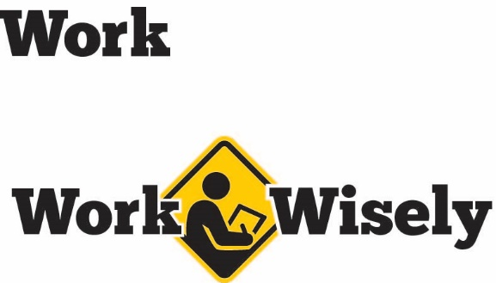
A mini training session for injury prevention
Quick Take on Safety

Aerial Lifts
TRAINING OVERVIEW AND OBJECTIVES
This training covers the importance of aerial lift inspections before starting work and general safety guidelines.
Purpose: This talk is intended to train employees about the importance of pre-start inspections and general safety to prevent injuries.
Preparation: Read and become familiar with this Quick Take; change as needed to reflect procedures and personnel in your department. Review the owner’s manual or manufacturer guidelines for the specific lift.
Handouts: Quick Review of Safety—Aerial Lifts
Notes: Scissor lifts do not require the use of fall protection equipment if the lift is protected by an OSHA standard guardrail. However, falls from all lifts are a hazard that should be addressed and mitigated.

SCRIPT TEXT
Recognize Hazards of Aerial Lifts
Aerial lifts are helpful tools, but they are not without hazard. Falls from height, tip overs, contact with objects or electrocution from overhead lines are some of the most common. Other hazards can include hitting objects or others during movement or ejection from the bucket.
Although these hazards can be serious, they can be controlled by following best practices. So listen carefully, your health and safety are important to us; we don’t want you to get hurt.
Pre-start Inspections
Before using the aerial lift, you should make sure that two separate inspections are always performed: an equipment check and a site inspection.
First, an equipment check should test controls, fluid levels, warning devices and other items identified in the owner’s manual. [Instructor Prompt: Consult the owner’s manual for more information about how to conduct a pre-start inspection and include the information here. Perhaps conduct the meeting near the lift and conduct an inspection together.]
Second, the site inspection should be conducted before operating in any new area. Ruts, slopes, unstable ground and debris can create conditions that adversely affect the stability of the lift. Therefore, they should be avoided or addressed. Make sure to search for overhead obstacles or energized lines and plan accordingly. The final consideration is weather, be aware of weather forecasts and make appropriate plans. Also, keep an eye on the weather, especially wind.
Best Practices to Manage Aerial Lift Hazards
- Always keep your feet on the floor of the platform or bucket; do not lean over or climb on guardrails.
- Never use ladders or other equipment to further extend your height from the lift platform.
- Always use fall restraint/arrest protection on the equipment that is attached to an identified location on the platform. A body harness should be worn and connected as soon as you or any other worker enters the platform or bucket. [Instructor Prompt: Show the tie-off point or ask the class to explain where the tie-off location is. Ask if everyone understands how to put on a harness.][Instructor Note: See note on scissor lifts.]
- Always have a thorough understanding of the specific load capacity, wind tolerance, reach and other limitations of the lift to be used. Do not exceed these limits. [Instructor Prompt: Tell the load capacity of the lifts in the facility.]
- Always be aware of what is in the travel path of the lift. Avoid electrical lines or other items within the path of travel; be aware of overhead objects as well.
- Never use aerial lift equipment in place of a crane to lift items. Avoid oversized or heavy loads on the platform or bucket.
- Never travel with the lift raised more than what is given in the manufacturer’s instructions. [Instructor Prompt: Explain the optimum driving height for the lifts in the facility.]
- Never travel with someone elevated in the platform or bucket unless the equipment is specifically designed for that use.
- If the lift has controls on both the platform and lower unit and a worker is on the platform, the lower controls should not be operated without the express consent of the worker on the platform except in an emergency.
- Always ensure that the lift is stable before beginning work. If equipment has outriggers, they should be positioned on a solid, level surface and the brakes should be set.
- If operations require the lift to be used on an incline, wheel chocks must be used only if they can be safely installed.
DISCUSSION QUESTIONS
- What activities pose the greatest risks when using the aerial lifts?
- How can we keep ourselves and others safe when using the aerial lift?

This document is intended for general purposes only and should not be construed as legal or coverage advice on any specific matter.
Developed and provided by Minnesota Counties Intergovernmental Trust


Aerial Lifts Session Planning and Review
Trainer |  | Training Date
Department(s)

TRAINING GOALS
- Employees are aware of hazards when using aerial lifts.
- Employees conduct detailed pre-start inspections of the equipment and work area.
- Employees understand and follow general best practices to avoid injury.
RESOURCES
- Minnesota Counties Intergovernmental Trust, “Public Works Loss Prevention Best Practices Guide,” Chapter 3, Aerial Lifts, MCIT.org/resource/ public-works-loss-prevention-best-practices-guide/, or “Solid Waste Management Loss Prevention Best Practices Guide,” Chapter 3, Aerial Lifts, MCIT.org /resource/solid-waste-management-loss-prevention-best-practices-guide/
- Occupational Safety and Health Administration, “Aerial Lifts Protect Yourself,” OSHA.gov
REVIEW
Did the training meet the stated goals?
How can the training be improved?
TRAINER COMMENTS

Attendance Record
Training Session | Aerial Lifts
Trainer |  | Training Date

Participant Name (printed) | Participant Signature

