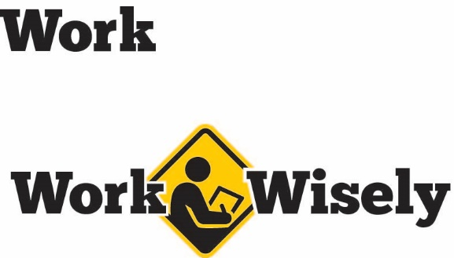
A mini training session for injury prevention
Quick Take on Safety

Cold and Flu Prevention
TRAINING OVERVIEW AND OBJECTIVES
Overview: Covers basics of illness prevention, including hand and respiratory hygiene, disinfectants and taking sick time.
Purpose: Remind employees of illness prevention tips to keep people safe and healthy.
Preparation: • Read and become familiar with this Quick Take. Change as needed to reflect policies, procedures and personnel in your department.
• Bring some hand sanitizer to use as an example. Review workplace sick policy and how to take a sick day.
Handouts: Quick Review of Safety—Illness Prevention
Notes: Numerous posters and other awareness materials are available from the Centers for Disease Control and Prevention and State of Minnesota Health Department. These can be used to supplement this Quick Take in staff areas.

Cold and Flu Prevention
Colds and flus can run swiftly through our families and work groups. These illnesses can lead to time away from work, irritability or more serious effects. Fortunately there are some steps we can take to help reduce the chances of catching or spreading a cold or the flu to others. So please pay attention; your health and safety is important to us.
Hand Hygiene
Hand washing is the single most effective practice people can do to prevent diseases. Unfortunately, many people either do not wash their hands or do not do so effectively. We should wash our hands before eating, and after using the toilet, blowing our nose, coughing, sneezing or touching garbage. It is good to wash hands both before and after preparing food or when caring for an ill individual.
According to the Centers for Disease Control and Prevention (CDC) to wash properly people should: [Instructor Prompt: Consider demonstrating in front of the class with soap or hand sanitizer]
- Wet hands with clean, running water (warm or cold), then turn off the tap and apply soap.
- Lather hands by rubbing them together with soap. Lather the backs of your hands, between fingers and under nails.
- Scrub hands for at least 20 seconds, consider humming the happy birthday song to yourself from beginning to end twice to approximate 20 seconds. Many people scrub or rub their hands too quickly.
- Rinse your hands under clean running water.
- Dry your hands using a clean towel or air dry them.
- Use hand sanitizer if soap is unavailable.
  - Apply hand sanitizer to palm of one and apply through all surface of the hands and continue rubbing hands together until they are dry.
Respiratory Hygiene or Cough Etiquette
Cough etiquette refers to the practice of covering your cough or sneeze to prevent disease transmission. This should be done when coughing or sneezing.
Ideally you cover your mouth and nose with a tissue when coughing and sneezing, dispose of the tissue after use and wash hands.
If a tissue is unavailable, cough into the back of your elbow or sleeve, not your hand. Again, wash your hands when able.
If you cough into your hands by mistake be sure to wash your hands promptly; avoid touching your eyes, nose or mouth until you wash your hands.
[Instructor Note: Several locations, such as hospitals or public health offices, may offer face masks to visitors to help minimize the risk of illnesses spreading to others. If this is available in your facility be sure to mention it as an option.]
Disinfectants
Keyboards, computer mice, door handles, railings and phones are common transmission points for germs. These should be regularly disinfected when possible, particularly during peak cold and flu season.
When using any disinfectant, be sure to follow appropriate product directions and personal protective equipment, such as gloves or eye protection if warranted. Please remember that disinfectants may not kill all germs.
Vaccination
To help prevent the flu, the CDC recommends the flu shot for everyone 6 months old and older with rare exceptions. These are offered every year at a variety of locations at low to no cost, depending on your insurance. [Instructor Note: It may be worth checking to see if your organization offers flu shots or if the employee health coverage covers the cost of flu shots.]
Staying Home
When sick with communicable illnesses, such as the flu (influenza), it is best to stay home, not only to care for yourself but to be avoid bringing the illness into the workplace and spreading it to others. [Instructor Prompt: Explain how employees can take sick days, how the policy works, etc.]
DISCUSSION QUESTIONS
- What else can we do to prevent illnesses?
- Where are we most likely to encounter germs?
- Where do we find cleaning supplies?
This document is intended for general purposes only and should not be construed as legal or coverage advice on any specific matter.
Developed and provided by Minnesota Counties Intergovernmental Trust


Cold and Flu Prevention Session
Planning and Review
Trainer |  | Training Date
Department(s)

TRAINING GOALS
- Employees are aware of and practice proper technique and frequency of hand hygiene.
- Employees are aware and practice proper respiratory hygiene.
- Employees understand how to use basic disinfectants.
- Employees are reminded of the process to take sick days, and encouraged to use them when sick.
RESOURCES
- “Handwashing,” Centers for Disease Control and Prevention (CDC)
- “Respiratory Hygiene/Cough Etiquette in Healthcare Settings,” Centers for Disease Control and Prevention
- “Hand Hygiene,” Minnesota Department of Health
- “Cover Your Cough,” Minnesota Department of Health
- “Protecting Workers Who Use Cleaning Chemicals,” Occupational Safety and Health Administration (OSHA) and National Institute of Occupational Safety and Health (NIOSH)
REVIEW
Did the training meet the stated goals?
How can the training be improved?
TRAINER COMMENTS

Attendance Record
Training Session | Cold and Flu Prevention
Trainer |  | Training Date

Participant Name (printed) | Participant Signature

