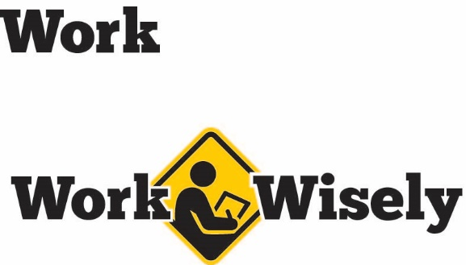
A mini training session for injury prevention
Quick Take on Safety

Fatigue in the Workplace
TRAINING OVERVIEW AND OBJECTIVES
Overview: Discusses the negative effects of fatigue in the workplace and methods to address them.
Purpose: To educate employees and employers to make positive changes to reduce fatigue and improve worker health and safety.
Preparation: Change as needed to reflect procedures and personnel in your department.
Handouts: Quick Review of Safety Fatigue in the Workplace
Notes: Scheduling has a great impact on an employee’s quantity and quality of sleep. Both time of day and duration of work hours has a strong effect on drowsiness and fatigue. Further resources on developing better schedules can be found in the National Institute for Occupational Safety and Health resource, “Work Schedules: Shift Work and Long Hours.”
Fatigue in the Workplace
We all know what it is like to be exhausted. Fatigue makes us less alert, decreases reaction time and can affect our thought processes and judgement similar to alcohol consumption.
According to National Safety Council surveys, 13 percent of all workplace accidents are at least partially attributed to drowsiness or fatigue. Drowsy driving is a factor in approximately 16 percent of fatal car crashes.
Insufficient sleep also has negative health effects, ranging from psychological disorders, such as anxiety or depression, and many diseases, such as obesity, hypertension, cardiovascular disease, cancer and diabetes.
Adults need an average of seven to nine hours of sleep each day. But in the United States, around 30 percent of adults report less than six hours of sleep a day. Fortunately, there are steps you can take to improve the quantity and quality of sleep.
So please pay attention. Your health and safety are important to us; we don’t want you to get hurt.
Signs of Fatigue
What are the signs of fatigue? Of course, weariness and sleepiness are the first things that comes to mind. Other signs may include difficulty concentrating, memory lapses and a slower reaction time.
Hazards of Fatigue
In addition to the potential health hazards, fatigue can also impair the ability to make decisions; and reduce our attention, communication skills and ability to handle stress. At the same time, it increases the likelihood of making errors in judgement. These hazards increase the chance of injury to yourself and others.
Preventing Fatigue
The Centers for Disease Control and Prevention recommend that adults between 18 and 60 years of old sleep seven or more hours each day. Here are some tips we can use to improve sleep and reduce fatigue in the workplace:
- Have a consistent sleep schedule. Go to bed at the same time and get up at the same time every day, even on days off.
- Try to keep your bedroom quiet and comfortable. Keep things quiet, dark and at a comfortable temperature. If working a night shift, consider using blackout curtains to keep the bedroom dark.
- Remove distracting electronics from the bedroom, such as TVs, computers and phones.
- Engage in relaxing activities, such as reading, about an hour before bed. If possible, avoid electronics as the light from the screens of most devices engages the brain and makes sleeping difficult.
- Use bright light to help manage circadian rhythms. Try to expose yourself to sunlight in the morning and avoid bright light before bed.
- Avoid eating large meals, or consuming caffeine or alcohol before bedtime.
- Get regular exercise during the day. It can help reduce stress and tire you out. Try to work stretching routines into your day. Stretching helps increase blood flow, which helps supply oxygen to our muscles and brain.
- Speak with your doctor about being screened for sleeping disorders, such as sleep apnea, if you continue to have trouble sleeping.
- Follow directions on medication. Pay attention to cautions regarding avoiding specific activities or other restrictions. Check labels or consult with your pharmacist.
- Periodically rotate tasks. Keep work fresh. If possible, set up a task rotation schedule if work is mundane and not stimulating.
Finally, talk to your supervisor if you are concerned about how fatigue is affecting you at work. [Instructor Prompt: This is a good opportunity to bring up the Employee Assistance Program (EAP) to help employees dealing with stress or other issues that may be contributing to fatigue.]

DISCUSSION QUESTIONS
- What are the signs of fatigue?
- How can fatigue increase the chance of injury to ourselves or others?
- What else can we do to get more sleep?
This document is intended for general purposes only and should not be construed as legal or coverage advice on any specific matter.
Developed and provided by Minnesota Counties Intergovernmental Trust


Fatigue in the Workplace Session Planning and Review
Trainer |  | Training Date
Department(s)

TRAINING GOALS
- Employees are aware of the hazards of fatigue.
- Employees understand some of the best practices to improve sleep.
RESOURCES
- National Safety Council, “Fatigue—You’re More Than Just Tired,” NSC.org
- National Institute for Occupational Safety and Health (NIOSH), “Work Schedules: Shift Work and Long Hours,” CDC.gov/niosh
- National Sleep Foundation, “Healthy Sleep Tips,” SleepFoundation.org
REVIEW
Did the training meet the stated goals?
How can the training be improved?
TRAINER COMMENTS

Attendance Record
Training Session | Fatigue in the Workplace
Trainer |  | Training Date

Participant Name (printed) | Participant Signature

