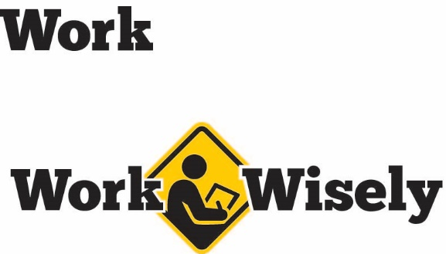
A mini training session for injury prevention
Quick Take on Safety

Holiday Decorations
TRAINING OVERVIEW AND OBJECTIVES
Overview: Covers common fire, tripping and electrical safety concerns related to holiday decorations.
Purpose: Raise awareness and prevent injuries and property damage related to holiday decorations.
Preparation: Read and become familiar with this Quick Take. Change as needed to reflect procedures and personnel in your department.
Have a safety ladder readily available and employees know where it is kept.
Handouts: Quick Review of Safety—Holiday Decorations

Holiday Decoration Hazards
[Instructor prompt: This Quick Take can encompass safety at home as well as work. Emphasize this during the instruction. Also review your organization’s rules and restrictions regarding holiday decorating in the workplace.]
Although decorations can add to the spirit of the holiday, they can pose risks of which you need to be aware Those risks include hazards related to fire; slips, trips and falls; electrical shocks; and choking. When we follow proper safety precautions, we can manage the risks of holiday decorations. Your health and safety is important to us, we don’t want you to get hurt.
The use of real trees, wreaths and garlands present one of the largest risks. These real decorations tend to dry out and become a significant fire hazard. They may also affect others with sensitivity to scent or those with allergies.
The Consumer Product Safety Commission estimates:
- Approximately 12,000 consumers are treated in hospital emergency departments nationwide due to holiday-related decorating incidents.
- Dried out Christmas trees are involved in hundreds of fires resulting in an average of 17 deaths and $13 million in property damage annually.
- Candle-related residential fires attended by fire departments are associated with an estimated annual average of 150 deaths and $385 million in property damage.
[Instructor note: Data is from 2010 and includes residential statistics.]
Prevention
- Real evergreen decorations should be avoided.
- Keep exits and exit hallways clear. Decorations must not block doorways or exit hallways.
- Exit signage or other safety equipment, such as fire extinguishers, must be easy to see and access.
- Decorations must not be hung from sprinkler heads or interfere with their operation. [Instructor prompt: Point out areas on the ceiling where decorations could hinder spray from sprinkler heads]
- Avoid all decorations with open flames or excessive heat.
- Do not place staples or nails through strings of holiday lights, power strips or extension cords.
- Follow manufacturer recommendations about how many sets of lights can be strung together.
- Any electric decorations or lights should be certified by an independent testing laboratory, such as Underwriters Laboratories (UL).
- Be aware of circuit loads. Do not plug too many items into a power strip or extension cord.
- Extension cords or power strips should be plugged directly into wall outlets and not each other.
- All powered lights or decorations should be unplugged at the end of the workday.
- Fire-resistant artificial trees are recommended to reduce the risk of fires. Be sure to look for the fire-resistant rating.
- Decorations on the tree, such as garland, should also be fire resistant.
- Secure trees and other large decorations to prevent them from tipping over.
- Any decorations in areas where children may be present should be located out of reach. Decorations should not be sharp, easily breakable or present a choking hazard. Avoid decorations that resemble candy.
- Avoid using electric lights on a metallic or electrically conductive tree.
- When putting up decorations, use safety ladders or ask others for help. Never use a chair or climb on a desk.
- Use safer lifting techniques when necessary to avoid strains, sprains and falls.
- Be mindful of extension cords, decorations or other items across walkways that could present a tripping hazard. If a cord crosses a walkway, it should be properly covered.
Hazard Reporting
- If you discover any of the items discussed, it is important to report them. We want to keep the area safe.
- You can report any hazards by speaking to your supervisor or by other means

DISCUSSION QUESTIONS
- How can we safely decorate for the holiday season?
- Which decorations or decorating activities present the greatest risks? How can we address them?
This document is intended for general purposes only and should not be construed as legal or coverage advice on any specific matter.
Developed and provided by Minnesota Counties Intergovernmental Trust


Holiday Decorations Session Planning and Review
Trainer |  | Training Date
Department(s)

TRAINING GOALS
- Employees understand the hazards associated with holiday decorations.
- Employees are aware of methods to reduce the hazards.
- Employees know the importance of reporting hazards to reduce the risks.
RESOURCES
- Consumer Product Safety Commission, “Holiday Home Decorating Guide,” CPSC.gov
- Electrical Safety Foundation International, “Holiday Decorating Safety,” ESFI.org
REVIEW
Did the training meet the stated goals?
How can the training be improved?
TRAINER COMMENTS

Attendance Record
Training Session | Holiday Decorations
Trainer |  | Training Date

Participant Name (printed) | Participant Signature

