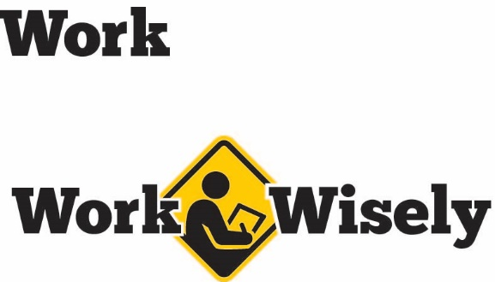
A mini training session for injury prevention
Quick Take on Safety

Needle Sticks and Sharps Injuries
TRAINING OVERVIEW AND OBJECTIVES
Overview: This training discusses the hazards of sharps use, and best practices for sharps use, disposal, and if injured.
Purpose: The intent is to help increase employee awareness of sharps hazards and follow best practices regarding sharps.
Preparation: • Read and become familiar with this Quick Take. Change as needed to reflect procedures and personnel in your organization or department.
- Consider reviewing the blood borne pathogens program of your organization.
- It can be helpful to have an empty sharps container or a needle with a safety device to demonstrate.
- Know the locations of sharps disposal containers at the facility.
Handouts: Quick Review of Safety—Sharps Disposal and Needle sticks
Notes: This presentation does not cover recordkeeping requirements for needle sticks. However, Minnesota OSHA requires that all needle sticks or sharps injuries from contaminated sources be included on the OSHA 300 log, whether an illness develops or not. Initially needle sticks from contaminated sources should be included on the “other recordable” category and updated to an illness or days away from work or work restriction as the situation changes. In other exposure situations outside of a needle stick, remember that exposure to another person’s blood or potentially infectious material does not itself constitute an injury or illness for the OSHA 300 log. Exposures from other sources do not need to be added to the 300 log unless an illness or diagnosis of blood borne pathogen occurs after the exposure.

Hazards of Sharps
Used needles and other sharps are dangerous to people and pets if not used and disposed of safely. Contaminated sharps can spread infections that cause serious health conditions. Some of the most common pathogens potentially transmitted through contaminated sharps are hepatitis B, hepatitis C and the human immunodeficiency virus (HIV).

Needle sticks and sharps injuries can be serious, but we can control and minimize the risks with prevention techniques, proper preparation and understanding. Your health and safety are important to us; we don’t want you to get hurt.

Sharps Use
When using needles, remember the following best practices to avoid a needle stick:
- Do not recap needles. It is too easy to miss the needle with the cap and poke a finger.
- Always use needle safety devices when available every time. [Instructor Prompt: Demonstrate the proper use of a needle safety device (if available).]
- Use needleless devices when available.
- Always pay attention to your surroundings and others when using needles. Many needles sticks occur when the patient moves unexpectedly or when sharps are disposed of improperly.
- Dispose of the needles in an approved sharps container; never dispose of a needle in the garbage.

Sharps Containers
Poor sharps disposal practices cause or contribute to many sharps injuries. Disposing of needles or contaminated sharps in garbage cans, recycling bins or flushing them down the toilet puts trash workers, janitors, sewage workers, housekeepers, household members, children and pets at risk of injury. Instead, dispose of needles or sharps in a sharps container.
A sharps container is designed to hold needles or other sharps and are marked with the biohazard symbol. [Instructor Prompt: Have an empty box to remind people of the appearance. Also, demonstrate how safely to add a sharp to the box. Tell the class where the boxes are located or ask employees to tell the locations and correct as needed.]
- Keep the sharps containers out of the reach of children.
- Do not empty one sharps container into another
- Do not overfill the sharps container. Many needle stick injuries occur when someone tries to overfill a container. If a container is full, please make sure you report it to have it changed.

Needle Sticks or Sharps Injury
If you experience a needle stick or sharps injury or are exposed to blood or other body fluid:
- Wash puncture or cuts with soap and water.
- Flush the nose, mouth or skin with water if there is a splash.
- Irrigate eyes with clean water, saline or sterile irrigates for eye exposure.
- Report the incident to your supervisor.
- Seek medical treatment.

DISCUSSION QUESTIONS
- How else can we prevent or reduce the risk of sharps injuries?
- What do we do if we experience a needle stick or sharps injury?
- What locations have sharps containers, and what other places may need them that do not have them?
- How do we report full sharps containers to be replaced?
This document is intended for general purposes only and should not be construed as legal or coverage advice on any specific matter.
Developed and provided by Minnesota Counties Intergovernmental Trust


Needle Sticks and Sharps Session Planning and Review
Trainer |  | Training Date
Department(s)

TRAINING GOALS
- Employees will be aware of the hazards of needle sticks and sharps injuries.
- Employees will understand how safely to use needles and safe disposal of needles and sharps.
- Employees will know how to treat themselves for initial injuries with needle sticks and cuts.
RESOURCES
- “Bloodborne Infectious Diseases: HIV/AIDS, Hepatitis B, Hepatitis C,” Centers for Disease Control and Prevention – National Institute for Occupational Health and Safety, CDC.gov/niosh/
- “Disposing of Needles and Syringes,” Minnesota Pollution Control Agency, PCA.state.mn.us
- “Minnesota Compliance: Recordkeeping Standard,” Minnesota Occupational Health and Safety Administration – Department of Labor and Industry, DLI.mn.gov
- “Information about Bloodborne Pathogens for Health Professionals,” Minnesota Department of Health, Health.state.mn.us
REVIEW
Did the training meet the stated goals?
How can the training be improved?
TRAINER COMMENTS

Attendance Record
Training Session | Needle Sticks and Sharps
Trainer |  | Training Date

Participant Name (printed) | Participant Signature

