
injury prevention
Quick Review of Safety
Portable Fuel Containers
PORTABLE GAS CAN REFUELING
- Ensure the container has a functioning cap that fits well and the container is free from signs of damage or cracks.
- Place containers on the ground when filling them to avoid a static charge from building.
- Keep containers away from other people and potential ignition sources. Do not smoke while refueling.
- Keep the nozzle in contact with the can during filling to avoid spills and to help prevent a static discharge.
- Do not overfill a gas container. Leave some room at the top to allow for expansion, particularly in hot weather.
- Address any spills promptly with appropriate cleanup materials and personal protective equipment if necessary.
EQUIPMENT REFUELING
- Turn off equipment, such as chainsaws, lawnmowers or snow blowers, and give the engine time to cool. Never refuel hot equipment.
- Keep away from other people and potential ignition sources. Do not smoke while refueling.
- Be aware of the location of nearby fire extinguishers prior to refueling.
- Proceed slowly to minimize the risk of spills.
- Do not overfill the tank. Allow room for expansion, particularly on hot days.
(Over)

injury prevention
Quick Review of Safety
Portable Fuel Containers
PORTABLE GAS CAN REFUELING
- Ensure the container has a functioning cap that fits well and the container is free from signs of damage or cracks.
- Place containers on the ground when filling them to avoid a static charge from building.
- Keep containers away from other people and potential ignition sources. Do not smoke while refueling.
- Keep the nozzle in contact with the can during filling to avoid spills and to help prevent a static discharge.
- Do not overfill a gas container. Leave some room at the top to allow for expansion, particularly in hot weather.
- Address any spills promptly with appropriate cleanup materials and personal protective equipment if necessary.
EQUIPMENT REFUELING
- Turn off equipment, such as chainsaws, lawnmowers or snow blowers, and give the engine time to cool. Never refuel hot equipment.
- Keep away from other people and potential ignition sources. Do not smoke while refueling.
- Be aware of the location of nearby fire extinguishers prior to refueling.
- Proceed slowly to minimize the risk of spills.
- Do not overfill the tank. Allow room for expansion, particularly on hot days.
(Over)

This document is intended for general purposes only and should not be construed as legal or coverage advice on any specific matter. Developed and provided by Minnesota Counties Intergovernmental Trust.


This document is intended for general purposes only and should not be construed as legal or coverage advice on any specific matter. Developed and provided by Minnesota Counties Intergovernmental Trust.

BONDING AND GROUNDING
When pumping or transferring flammables with flash points less than 100 degrees, follow these bonding and grounding steps:
- Connections to bulk containers should have a metal-to-metal connection with an earth ground that uses a grounding wire.
- When connecting grounding and bonding wires, confirm metal-to-metal contact. Look for paint or rust, as this can block the flow of electrical energy.
- When transferring from a bonded container to a portable safety can, ensure that there is a metal-to-metal connection with a bonding wire to the safety container. This wire is often attached with spring-type clamps.
- If polyethylene containers are used, they should be grounded. Most approved polyethylene safety containers have a grounding lug for this connection.
- Periodically inspect wires and connections to ensure grounding is not interrupted.
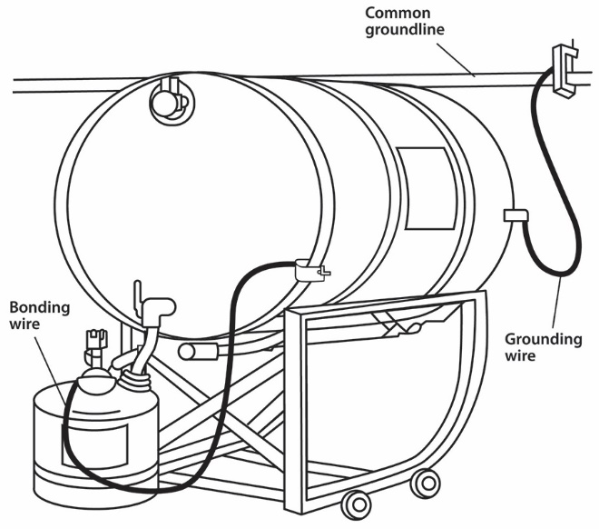
BONDING AND GROUNDING
When pumping or transferring flammables with flash points less than 100 degrees, follow these bonding and grounding steps:
- Connections to bulk containers should have a metal-to-metal connection with an earth ground that uses a grounding wire.
- When connecting grounding and bonding wires, confirm metal-to-metal contact. Look for paint or rust, as this can block the flow of electrical energy.
- When transferring from a bonded container to a portable safety can, ensure that there is a metal-to-metal connection with a bonding wire to the safety container. This wire is often attached with spring-type clamps.
- If polyethylene containers are used, they should be grounded. Most approved polyethylene safety containers have a grounding lug for this connection.
- Periodically inspect wires and connections to ensure grounding is not interrupted.

