This document is intended for general purposes only and should not be construed as legal or coverage advice on any specific matter. Developed and provided by Minnesota Counties Intergovernmental Trust.


This document is intended for general purposes only and should not be construed as legal or coverage advice on any specific matter. Developed and provided by Minnesota Counties Intergovernmental Trust.

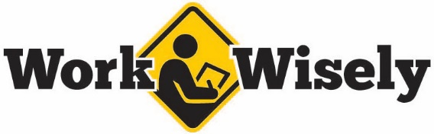
injury prevention
Quick Review of Safety
Safe Mail Handling
HAZARD RECOGNITION
Trust your instincts; if something feels wrong, don’t ignore it.
For mailed letters and packages some standard indicators include:
- Excessive postage
- Misspelled common words
- No return address or strange return address
- Sent by someone unfamiliar or unexpected
- Incorrect titles or mailed to a title rather than a specific person
- Restrictive markings such as “personal,” “confidential,” or “do not X-ray”
- Excessive tape or packing material
- Oily stains, discoloration or strange odors
- Lopsided or uneven packages or envelopes of unusual weight
- Protruding wires
- Unusual powders or substances
BEST PRACTICES
- Do your best to remain calm. The vast majority of these incidents tend to be nothing more than false alarms or hoaxes.
- Do not open, smell or taste the contents.
- Do not show the item to others.
- Back away and do not handle the item any more.
- Isolate the area immediately.
- Notify a supervisor and law enforcement.
- Notify facilities or maintenance to stop heating, ventilation or air conditioning systems to prevent hazards from spreading throughout a location.
- Wash your hands with soap and water.
injury prevention
Quick Review of Safety
Safe Mail Handling
HAZARD RECOGNITION
Trust your instincts; if something feels wrong, don’t ignore it.
For mailed letters and packages some standard indicators include:
- Excessive postage
- Misspelled common words
- No return address or strange return address
- Sent by someone unfamiliar or unexpected
- Incorrect titles or mailed to a title rather than a specific person
- Restrictive markings such as “personal,” “confidential,” or “do not X-ray”
- Excessive tape or packing material
- Oily stains, discoloration or strange odors
- Lopsided or uneven packages or envelopes of unusual weight
- Protruding wires
- Unusual powders or substances
BEST PRACTICES
- Do your best to remain calm. The vast majority of these incidents tend to be nothing more than false alarms or hoaxes.
- Do not open, smell or taste the contents.
- Do not show the item to others.
- Back away and do not handle the item any more.
- Isolate the area immediately.
- Notify a supervisor and law enforcement.
- Notify facilities or maintenance to stop heating, ventilation or air conditioning systems to prevent hazards from spreading throughout a location.
- Wash your hands with soap and water.

