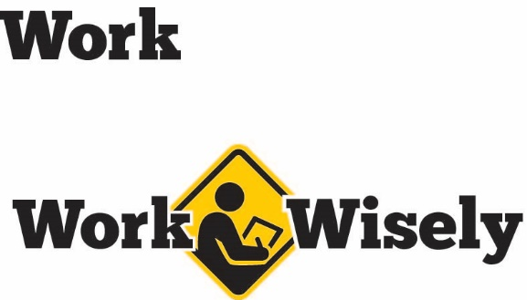
A mini training session for injury prevention
Quick Take on Safety

Safer Travel in Winter Storms
TRAINING OVERVIEW AND OBJECTIVES
Overview: Covers the basics of traveling in winter storms, including preparedness, such as emergency kits, and tips to reduce the risks.
Purpose: Prepare employees for winter storms and how to survive a storm if stranded in a car.
Preparation: Read and become familiar with this Quick Take. Change as needed to reflect procedures and personnel in your department.
Handouts: Quick Review of Safety—Winter Storm Safety

Hazards
Winter storms wreak havoc on utilities, roads and cars. They can reduce visibility, bring bitter cold, knock out power and make travel difficult or impossible. Staying inside until the storm passes is often the safest approach, but this is not always possible. Fortunately, there are some steps you can take to minimize the risks from winter storms, so pay careful attention. Your health and safety are important to us; we don’t want you to get hurt.
Preparedness
The most important thing you can do is to plan for winter storms. Before traveling:
- Review the weather forecasts for the entire route. If a trip is scheduled during inclement weather, consider rescheduling to avoid the hazards of being on the road.
- Be prepared for changing conditions by dressing in multiple layers.
- Wear good footwear that will keep you warm and dry but that also offers good tread to minimize slips, trips and falls.
- Keep a well-maintained vehicle with adequate gas, windshield washing fluid, unobstructed lights and signals, and proper tire pressure.
- Keep a clean windshield and have extra windshield washing fluid on hand.
- Consider using snow-tires or other high traction tires for the winter season.
- Bring a cell phone or other communications device and, if possible, let others know your route and when to expect you.
- Prepare a winter survival kit in a small, covered container including:
  - Small, sharp knife and plastic spoons
  - Red bandanna or cloth (to attract attention)
  - Safety pins
  - Whistle
  - Cell phone charger
  - Plastic flashlight and spare batteries. Here’s a tip: Reverse the batteries in the flashlight until you need it to maintain their charge.
  - Small first-aid kit
  - Small candles and matches
  - Small packages of food that can be eaten hot or cold that last a long time such as raisins, miniature candy bars or chocolate, wrapped hard candies and energy or granola bars.
The following items are also helpful to store in a vehicle during winter:
- Jumper cables
- Basic tools
- Sand, cat litter, chicken grit or other abrasive to provide more traction
- Shovel
- Tow cables or chain
- Sleeping bag or blankets
- Road flares or reflectors
- Snow suit and heavy boots
Best Practices
[Instructor Prompt: These winter travel best practices are typically well-known by people living in Minnesota, consider eliciting the group for suggestions instead of reading.)
When traveling in a winter storm:
- Do not travel unless it is necessary; wait until roads are plowed or the storm is over.
- Travel slowly and increase following distance between you and the car ahead of you.
- Accelerate and decelerate slowly.
- Take turns slowly and gradually.
- Turn in the direction of the skid.
- If your vehicle has anti-lock brakes, apply constant pressure to the brakes and steer in the direction you want to go.
- If your vehicle does not have anti-lock brakes, brake with a gentle pumping action.
- Be able to see and be seen.
If in an accident or your vehicle breaks down:
- Move vehicle out of traffic and park.
- Call 911 for any emergencies.
- Stay in your vehicle.
- Remember to remain calm. The storm will end, and you will be found.
- Keep snow off of the radiator and away from the exhaust pipe.
- Keep fresh air in the vehicle, wet or wind-driven snow can plug the exhaust system and cause deadly carbon monoxide gas to enter the vehicle.
Don’t expect comfort; it is better to be cold and awake rather than warm and sleepy.

DISCUSSION QUESTIONS
- What can we do to maintain communication in the event of an emergency?
This document is intended for general purposes only and should not be construed as legal or coverage advice on any specific matter.
Developed and provided by Minnesota Counties Intergovernmental Trust


Safer Travel in Winter Storms Session
Planning and Review
Trainer |  | Training Date
Department(s)

TRAINING GOALS
- Employees are reminded of the best ways to prepare for traveling in winter.
- Employees understand the importance and best practices when preparing a winter survival kit.
- Employees know the basics of how to shelter in a winter storm after an accident or break down.
RESOURCES
- “Winter Survival in Your Car,” Available in Chapter 1 of “Discussion Items and Resources for Employees Who Work Off Site” at MCIT.org
- Minnesota Department of Public Safety, “Winter Driving,” DPS.mn.gov.
REVIEW
Did the training meet the stated goals?
How can the training be improved?
TRAINER COMMENTS

Attendance Record
Training Session | Safer Travel in Winter Storms
Trainer |  | Training Date

Participant Name (printed) | Participant Signature

