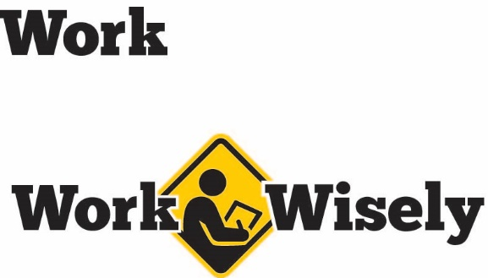
A mini training session for injury prevention
Quick Take on Safety

Speaking Up for Safety
TRAINING OVERVIEW AND OBJECTIVES
Overview: Discusses the problems with silence in the workplace as it relates to safety and provides methods to encourage employees to speak up about safety.
Purpose: Help inform employees about the negative consequences of silence in an effort to improve communication and reduce injuries.
Preparation: • Read and become familiar with this Quick Take. Change as needed to reflect procedures and personnel in your department.
• Review and become familiar with hazard and injury reporting procedures within your organization.
Handouts: Quick Review of Safety: Speaking Up for Safety
Notes: Many people avoid reporting injuries due to concerns of having to take unpaid time off for recovery or from the costs associated with medical care should workers’ compensation claims be denied. Much of this is outside of the control of supervisors or management; however, being familiar with sick leave and paid-time off options and including them briefly in the training can help alert people to options they may have been unaware of. Consider other obstacles to communication within the organization and make plans to address them prior to giving this training.
Silence
You’ve probably heard the phrase, “If you see something, say something” on signs at the airport. The same is true in the workplace. After serious workplace injuries, the investigation often reveals that various hazards, unsafe behaviors, near misses and even minor injuries were not reported. Had they been reported, the hazards could have been addressed and the serious injury could have been avoided.
Communication is vital to preventing injuries and maintaining a safe work environment. Silence prevents this communication. So please speak up. Your safety and health are important to us; we don’t want you to get hurt.
Combatting Silence
There are many reasons people may choose to remain quiet rather than alerting others about safety hazards and behaviors. Let’s talk about some of the most common reasons and why they should be avoided:
- Concern of getting others in trouble.
  - To help avoid this, be sure first to tell the person of your concerns. This can give your co-worker the opportunity to refrain from unsafe acts or to understand the reason behind safe work practices.
  - If this does not work, reporting to management can help keep that particular individual safe, as well as other co-workers and the public.
- Fear of being seen as troublesome: Some are concerned about being labeled as a complainer or of “rocking the boat.” Also, some people will avoid reporting minor injuries for similar reasons or from the thought that a certain amount of pain is part of the job.
  - Turning a blind eye to hazards or unsafe actions does not help anyone and only increases the likelihood of accidents or injuries in the future. There are no repercussions for reporting unsafe actions or behaviors.
  - You are not expected to ignore injuries and push through. Small injuries can grow into larger ones and are much easier to deal with if handled early. Be sure to report so we can address those injuries or hazards early.
[Instructor Note: Hazards need not be reported in person. E-mail, forms or other options can make the process more anonymous. See what options work well for your organization. If these measures are available, try to keep the reporter anonymous.]
- Not my job: Some feel it is not their responsibility to voice concerns and that supervisors should be responsible for observing safety hazards and behaviors.
  - Remember everyone has the responsibility to be their own safety advocate and report safety hazards. It is everyone’s responsibility to work safely and look out for each other and the public.
- Unsure how to report or difficulty reporting: Some people may want to report but do not know how or may find the system too complicated or time consuming to use.
  - Reporting can be as simple as just letting [me/your supervisor] know about a possible hazard. [Instructor Prompt: Other reporting procedures should be discussed here.]
- Not recognizing the hazard: Sometimes hazards are not reported because employees do not recognize them.
  - If you are unsure about whether something is a hazard, it is always best to assume it is. Trust your gut. Feel free to ask if something is hazardous or could be done more safely. You may identify a new hazard or safer way to complete a task.
DISCUSSION QUESTIONS
- What are some barriers to communicating about safety issues?
- How can we help improve the safety hazard reporting process?
- What are the most common unsafe acts to watch for?
ADDITIONAL ACTIVITIES
- How can we bring up safety concerns to each other in a non-accusatory way?
[Instructor Note: Here are some examples below]
  - “Let me help you with lifting that. Let’s do a team lift.”
  - “That looks heavy and awkward; let’s get a cart to move it.”
  - “I’ll get you some safety glasses.”
  - “Let’s put the guard on that machine before we use it.”

This document is intended for general purposes only and should not be construed as legal or coverage advice on any specific matter.
Developed and provided by Minnesota Counties Intergovernmental Trust


Speaking Up for Safety Session Planning and Review
Trainer |  | Training Date
Department(s)

TRAINING GOALS
- Inform employees about the risks of remaining silent about safety hazards.
- Give some of the most common excuses for remaining silent and reasons to speak up.
- Explain the hazard or injury reporting process to employees.
RESOURCES
- “Speaking Up,” by Ashley Johnson, Oct. 1, 2013, SafetyandHealthMagazine.com.
- Work Wisely safety culture campaign materials, MCIT.org/work-wisely/.
REVIEW
Did the training meet the stated goals?
How can the training be improved?
TRAINER COMMENTS
[comments added here]

Attendance Record
Training Session | Speaking Up for Safety
Trainer |  | Training Date

Participant Name (printed) | Participant Signature

