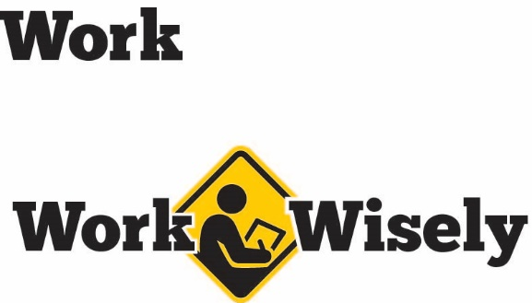
A mini training session for injury prevention
Quick Take on Safety

Take Your Time for Safety
TRAINING OVERVIEW AND OBJECTIVES
Overview: Explains the hazards that result from working hastily and encourages employees to be mindful of the speed of their work.
Purpose: Prevent injuries by reminding employees to follow all steps, use all protective equipment and consider what they are doing at the time instead of rushing through their work.
Preparation: Read and become familiar with this Quick Take. Change as needed to reflect procedures and personnel in your department.
Handouts: Quick Review of Safety—Take Your Time for Safety

Being in a hurry to complete tasks is something to which everyone can relate. However, rushing increases the risks of mistakes and of skipping important steps. Numerous injuries can at least in part be traced to being in a hurry.
Rushing also can result in having to do the task again, which means that it actually made the task take longer. We’d rather have you take your time and do the job safely the first time. So please pay attention. Your safety and health are important to us; we don’t want you to get hurt.
Risks of Rushing Your Work
Let’s discuss some of the potential consequences of rushing:
- It reduces focus on what you are doing. Your mind may be on other things, rather than on what you are doing at the moment. This can lead to making simple mistakes.
- Hurrying increases the risk of injury to yourself and others, especially when taking shortcuts. The same is true with the use of personal protective equipment and other safety tools and equipment. Just because it may be take a few moments to find and don safety glasses, for example, does not mean it is the appropriate to skip the step for the sake of quickly completing a task. Please do not take shortcuts.
- Using equipment outside of their intended purposes is another way haste creeps into our work. Sometimes it takes time to retrieve the right tool for the job. Just because a rolling chair is close does not mean it is the right item to stand on to retrieve something from a high shelf. Using what is on hand to complete a task in a hurry can greatly increase risk. Be sure to use the correct tools, such as a step stool or ladder, for the job.
- Often the last step of any task is cleaning up the work area and may be left undone. Poor housekeeping increases the chance of slips, trips and falls, can block important routes of egress and make it difficult to find items. Take the time to put tools and materials away properly and clean up any spills.
[Instructor Note: Poor housekeeping can be a great indicator of rushed work and/or complacency, as well as other safety concerns. Consider reviewing the complacency Quick Take and the housekeeping Quick Take with staff.]
- As with other hazards, rushing to complete a task may not have any immediate negative outcomes. This lack of consequence can then make rushing seem less risky and further encourage doing so in the future. This can build over time and makes the process less safe the more complacency builds.
So to prevent yourself and others from getting hurt, I want you to take your time, follow all the steps for the task and work safely. Spending a bit more time in the short term often saves time in the long run and helps keep yourself and others safe.
If there is some question as to the reason certain steps are included with a task or procedure, please ask. It is possible we can find a better way of doing things.

DISCUSSION QUESTIONS
- What are some of the tasks that run the greatest risk of rushing through them?
- How can we overcome the temptation to hurry our work?
This document is intended for general purposes only and should not be construed as legal or coverage advice on any specific matter.
Developed and provided by Minnesota Counties Intergovernmental Trust


Take Your Time for Safety
Session Planning and Review
Trainer |  | Training Date
Department(s)

TRAINING GOALS
- Employees understand the hazards of rushing to complete work.
- Remind employees to slow down and work safely.
RESOURCES
- MCIT Work Wisely safety culture campaign materials, MCIT.org/work-wisely/
- Quick Takes on Safety for housekeeping and complacency, MCIT.org/quick-takes-on-safety/
REVIEW
Did the training meet the stated goals?
How can the training be improved?
TRAINER COMMENTS

Attendance Record
Training Session | Take Your Time for Safety
Trainer |  | Training Date

Participant Name (printed) | Participant Signature

