This document is intended for general purposes only and should not be construed as legal or coverage advice on any specific matter. Developed and provided by Minnesota Counties Intergovernmental Trust.

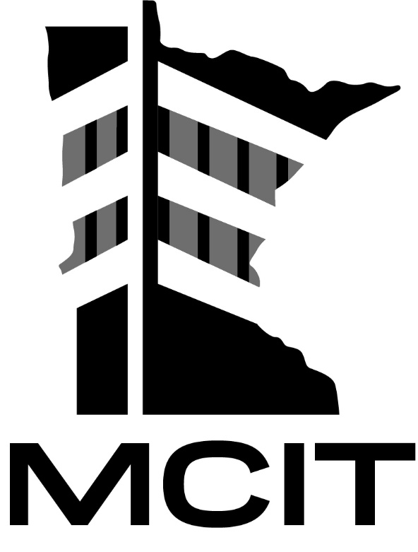
This document is intended for general purposes only and should not be construed as legal or coverage advice on any specific matter. Developed and provided by Minnesota Counties Intergovernmental Trust.

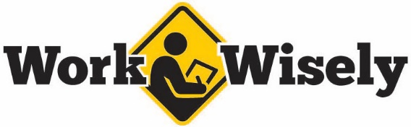
injury prevention
Quick Review of Safety
Take Your Time for Safety
Being in a hurry to complete tasks increases the risks of injury or mistakes. Be sure to take your time and focus on the task at hand.
ACTIONS TO AVOID
- Rushing and/or taking shortcuts to save time. This can lead to reduced focus on what you are doing therefore increasing the risk of injury to yourself and others. Slow down and if you are unsure of why certain steps are included please ask.
- Using equipment outside of their intended purposes. Not taking the time to get the proper equipment or tools can greatly increase the risk as well as cost more time and money in the end. Be sure to use the right tools for the job.
- Lack of or poor housekeeping. This can lead to increased chance of injury, block egress routes and make finding items difficult. Take the time to put things away properly and clean up.
- Increased chance of complacency. Rushing through a task may not have any immediate negative outcomes, which can create a sense of complacency. This complacency can create further safety concerns.
Take your time, follow the steps and procedures for a task and remember that spending more time in the short term often saves time in the long term. It also helps keep yourself and others safe.

injury prevention
Quick Review of Safety
Take Your Time for Safety
Being in a hurry to complete tasks increases the risk of injury or mistakes. Be sure to take your time and focus on the task at hand.
ACTIONS TO AVOID
- Rushing and/or taking shortcuts to save time. This can lead to reduced focus on what you are doing, therefore increasing the risk of injury to yourself and others. Slow down, and if you are unsure of the reasons certain steps are included, ask your supervisor.
- Using equipment outside of their intended purposes. Not taking the time to get the proper equipment or tools can greatly increase the risk, as well as cost more time and money in the end. Be sure to use the right tools for the job.
- Not cleaning up after yourself. This can lead to increased chance of injury, block egress routes and make finding items difficult. Take the time to put tools and materials away properly and clean up.
- Getting complacent about risky behavior. Rushing through a task may not have any immediate negative outcomes, which can create a sense of complacency. This complacency can create further safety concerns.
Take your time, follow the steps and procedures for a task, and remember that spending more time in the short term often saves time in the long run. It also helps keep yourself and others safe.

