
A mini training session for injury prevention
Quick Take on Safety

Tick Bite Prevention
TRAINING OVERVIEW AND OBJECTIVES
Overview: Discusses tick borne diseases, preventive measures, tick identification and tick removal.
Purpose: Refreshes employees about tick-related hazards and prevention methods with the goal of reducing tick borne illness.
Preparation: Read and become familiar with this Quick Take. Change as needed to reflect procedures and personnel in your department.
Prior to conducting this training, the trainer should gather tick ID cards for participants.
Handouts: Quick Review of Safety—Tick Bite Prevention
Tick ID Cards

Tick Hazards
The main tick hazards in Minnesota are diseases, such as Lyme disease or human anaplasmosis. These tick borne diseases are bacterial and are transmitted from infected blacklegged (deer) ticks. Lyme disease and human anaplasmosis can be treated with antibiotics, but if left untreated, they can be serious.
Early identification and treatment is key.
You may have heard about another tick borne disease in Minnesota that causes an allergy to red meat. This illness is known as alpha-gal syndrome or mammalian meat allergy and has no known cure. It may last for a lifetime in some people but in others disappear over time. This illness can be spread through the bite of the lone star tick.
Tick bites can have serious consequences, we can avoid or control them with proper preparation and understanding of prevention techniques. Your health and safety is important to us; we don’t want you to get hurt.
Prevention
- Tick season in Minnesota is split into two times of the year corresponding to the tick lifecycle. The first is April through July, and the second is September through October. Be particularly vigilant during these months.
- Ticks live in wooded and brushy areas with high grass or leaf litter, so avoid these areas whenever possible.
- Ticks crawl up and latch on rather than dropping from trees. Pay special attention to securing pants, socks and shoes by tucking pants into the top of socks or boots.
- Wear light colored clothes to make it easier to spot ticks.
- Use repellants that contain no more than 30 percent DEET. Higher concentrations offer few added benefits.
- Treat clothing with permethrin-based products, but do not use permethrin on skin.
- Follow manufacturer directions for all repellants, particularly regarding application frequency.
- Check yourself for ticks thoroughly. Ticks need to be attached for 12 to 48 hours to transmit diseases.
- Tumble dry clothing in a dryer on high heat for at least 10 minutes to kill ticks on clothing; if clothes are damp additional time may be needed.
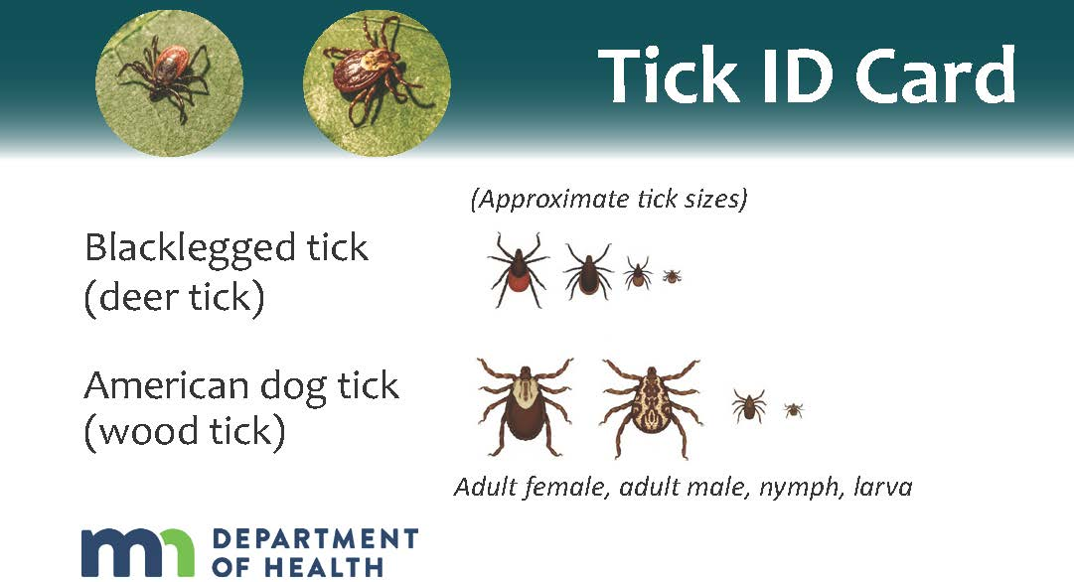
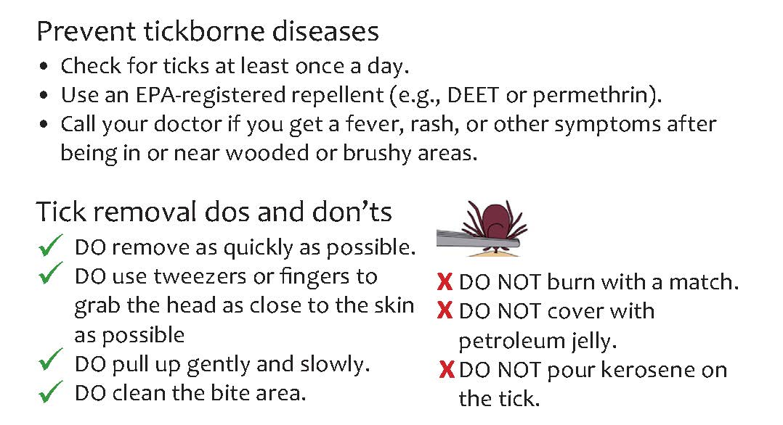
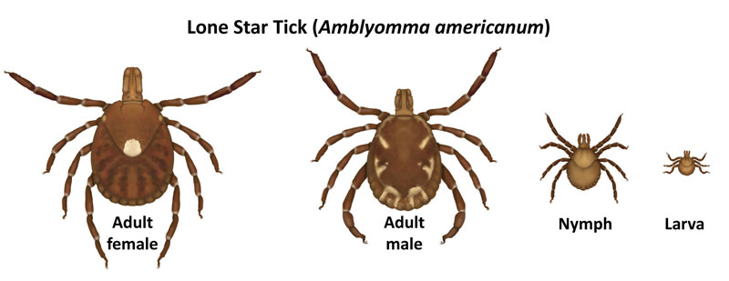
Identification
- Use the tick ID cards I handed out to identify ticks you may encounter. [Instructor: Tick Card is shown at right, as well as lone star tick identifying images.]
- Blacklegged ticks are black or reddish brown. American dog ticks are brown with whitish or gray markings. The female lone star tick is brown with a white dot on the back.
- Blacklegged ticks are known to transmit Lyme disease and human anaplasmosis. The lone star tick can transmit an allergy to red meat and other diseases.
Removal and Health Care
- If you find a tick latched onto you, use fine-tipped tweezers to grasp the tick as close to the surface of the skin as possible. Do not squeeze the tick’s body.
- Pull upward with a steady even speed.
- After removing the tick, clean the bite area and wash your hands with rubbing alcohol, iodine scrub or with soap and water.
- Store the tick in a sealed jar to be identified and tested later or dispose of the tick.
  - When disposing of a tick, submerse it in alcohol, wrap it tightly in tape, or flush it down the toilet. Avoid crushing it in your fingers.
- If bitten by a tick at work, report it to your supervisor as soon as possible.
- If a rash develops near the tick bite area or you come down with fever within several weeks, see a doctor.

DISCUSSION QUESTIONS
- What steps can we take to prevent tick bites?
- What should you do if you find an attached tick while working? [Instructor note: Remember to include reporting procedures.]
This document is intended for general purposes only and should not be construed as legal or coverage advice on any specific matter.
Developed and provided by Minnesota Counties Intergovernmental Trust


Tick Bite Prevention Session Planning and Review
Trainer |  | Training Date
Department(s)

TRAINING GOALS
- Employees understand the hazards of tick bites.
- Employees are aware of how to best prevent tick bites.
- Employees know how to safely remove ticks.
- Employees understand the importance and process for reporting work related tick bites.
RESOURCES
- Minnesota Department of Health, Tickborne Diseases, Health.state.mn.us
- Minnesota Department of Health, “Tick ID Cards,” Health.state.mn.us
- Centers for Disease Control and Prevention, “Ticks,” CDC.gov
- Minnesota Counties Intergovernmental Trust, “Stop Tick Bites to Prevent Lyme Disease,” MCIT.org/resource/
REVIEW
Did the training meet the stated goals?
How can the training be improved?
TRAINER COMMENTS

Attendance Record
Training Session | Tick Bite Prevention
Trainer |  | Training Date

Participant Name (printed) | Participant Signature

