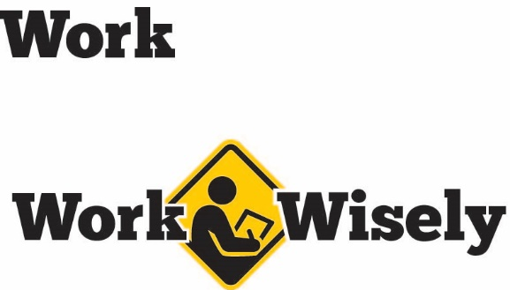
A mini training session for injury prevention
Quick Take on Safety

Procedures for After an Auto Accident
TRAINING OVERVIEW AND OBJECTIVES
Overview: Addresses what to do after an auto accident, including exchanging information and reporting accidents.
Purpose: Employees driving cars for work know and understand the proper procedures for gathering information and reporting accidents.
Preparation: • Read and become familiar with this Quick Take. Change as needed to reflect procedures and personnel in your department.
• Review procedures within your organization and further details about whom to contact within the organization to submit claims to MCIT.
• Discuss policies regarding speaking to the media.
Handouts: Quick Review of Safety—After an Auto Accident.

Hazards
Although the number of traffic accidents can be reduced with careful and attentive driving, accidents can and will still occur. According to the Department of Public Safety, in Minnesota during 2017, there were more than 78,000 traffic crashes with nearly 360 fatalities and over 29,000 injuries.
With this in mind, it is important to briefly discuss what to do if you are involved in an auto accident. So please listen carefully, your health and safety are important to us; we want you to be prepared.
First Steps
The first step after an accident is if possible to move the vehicle out of traffic to a safe location and turn off the engine. Do not leave the scene of the accident!
Then ensure that you and others receive necessary medical attention. This will likely involve calling 911 for an ambulance or other emergency response. The Good Samaritan law in Minnesota only requires that you call 911 for assistance in the event of a medical emergency and not to put yourself or others in danger or to act beyond your skills.
This document is intended for general purposes only and should not be construed as legal or coverage advice on any specific matter.
Developed and provided by Minnesota Counties Intergovernmental Trust


Although not required by Minnesota law in all situations, we recommend that you contact law enforcement to file a report.
Exchanging Information
After an auto accident in Minnesota, drivers must give information to other parties involved and gather information from them. When exchanging details, do not admit fault, as additional information may prove otherwise. Avoid making any statements that could be misunderstood, misinterpreted or used against you.

The key information to gather is:
- Name, address and contact details
- Driver’s license number(s)
- License plate number(s)
- Auto insurance information
Whenever possible, it is recommended to get the contact information from nearby witnesses and to photograph the scene of the accident, including damage and conditions. [Instructor Note: Make note of any policies regarding use of entity-provided mobile phones or devices for taking pictures.] Remember to note the date, time, conditions and verbal statements made by the other parties involved.

Do not rely on law enforcement to gather this information for you, but do not hinder first responders in an effort to gather this information. Obtaining medical attention and the safety of the accident scene should take precedence. [Instructor Note: Discuss the organization’s policy about responding to the press.]

[Instructor Note: MCIT provides vehicle incident kits where insurance information can be written and kept.]
If you hit an unoccupied vehicle, you must attempt to locate the owner and follow the procedures we just discussed. If unsuccessful, you may leave a note indicating the following:
- Your name and contact information
- Brief description of the accident

Insurance Carrier
[Instructor Note: Employees using their own vehicles need to use their own insurance in the event of an accident.]
Notify your auto insurance company if involved in an accident when driving your personal vehicle. If using a [entity] vehicle, please contact a supervisor or manager to begin the claim process for both auto and/or workers’ compensation.
DISCUSSION QUESTIONS
- What is the first thing to do after an accident?
- Who should you talk to report an accident?

Procedures After an Auto Accident Session Planning and Review
Trainer |  | Training Date
Department(s)

TRAINING GOALS
- Employees are aware of their responsibilities when getting into an accident.
- Employees do not make the situation worse by responding negatively.
- Accidents are reported correctly and timely to the right organizations.
RESOURCES
- Minnesota Office of the Revisor of Statutes, 604A.01 Good Samaritan Law, Revisor.mn.gov
- Vehicle Incident Kits, available from MCIT at no charge. Visit MCIT.org to request kits.
REVIEW
Did the training meet the stated goals?
How can the training be improved?
TRAINER COMMENTS

Attendance Record
Training Session | Procedures for After an Auto Accident
Trainer |  | Training Date

Participant Name (printed) | Participant Signature

